- Write a program to perform various operations in the array:
- Insertion
- Deletion
- Display
#include <stdio.h>
void main() {
int arr[100], n, i, choice, pos, value;
printf("Enter number of elements: ");
scanf("%d", &n);
printf("Enter elements:\n");
for(i = 0; i < n; i++){
scanf("%d", &arr[i]);}
do {
printf("\n1. Insert\n2. Delete\n3. Display\n4. Exit\n");
printf("Enter choice: ");
scanf("%d", &choice);

switch(choice) {
case 1:
printf("Enter position and value: ");
scanf("%d %d", &pos, &value);
for(i = n; i >= pos; i--)
arr[i] = arr[i-1];
arr[pos-1] = value;
n++;
break;

case 2:
printf("Enter position to delete: ");
scanf("%d", &pos);
for(i = pos-1; i < n-1; i++)
arr[i] = arr[i+1];
n--;
break;

case 3:
printf("Array elements:\n");
for(i = 0; i < n; i++)
printf("%d ", arr[i]);
break;
}
} while(choice != 4);
}
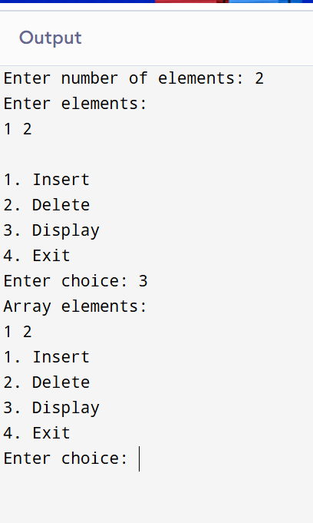
- Write a program to find the arithmetic operations on matrices :
- Sum and subtraction
- Product of 2 matrices
- Transpose of a matrix
#include <stdio.h>
void main() {
int a[10][10], b[10][10], sum[10][10], sub[10][10], mul[10][10];
int r1,c1,r2,c2,i,j,k;
printf("Enter rows and columns of Matrix A: ");
scanf("%d %d",&r1,&c1);
printf("Enter elements of Matrix A:\n");
for(i=0;i<r1;i++)
for(j=0;j<c1;j++)
scanf("%d",&a[i][j]);
printf("Enter rows and columns of Matrix B: ");
scanf("%d %d",&r2,&c2);
printf("Enter elements of Matrix B:\n");
for(i=0;i<r2;i++)
for(j=0;j<c2;j++)
scanf("%d",&b[i][j]);
if(r1==r2 && c1==c2) {
for(i=0;i<r1;i++)
for(j=0;j<c1;j++) {
sum[i][j]=a[i][j]+b[i][j];
sub[i][j]=a[i][j]-b[i][j];
}
printf("\nSum:\n");
for(i=0;i<r1;i++){
for(j=0;j<c1;j++)
printf("%d ",sum[i][j]);
printf("\n");
}

printf("\nSubtraction:\n");
for(i=0;i<r1;i++){
for(j=0;j<c1;j++)
printf("%d ",sub[i][j]);
printf("\n");
}
}

if(c1==r2) {
for(i=0;i<r1;i++)
for(j=0;j<c2;j++){
mul[i][j]=0;
for(k=0;k<c1;k++)
mul[i][j]+=a[i][k]*b[k][j];
}

printf("\nProduct:\n");
for(i=0;i<r1;i++){
for(j=0;j<c2;j++)
printf("%d ",mul[i][j]);
printf("\n");
}
}

printf("\nTranspose of Matrix A:\n");
for(i=0;i<c1;i++){
for(j=0;j<r1;j++)
printf("%d ",a[j][i]);
printf("\n");
}
}
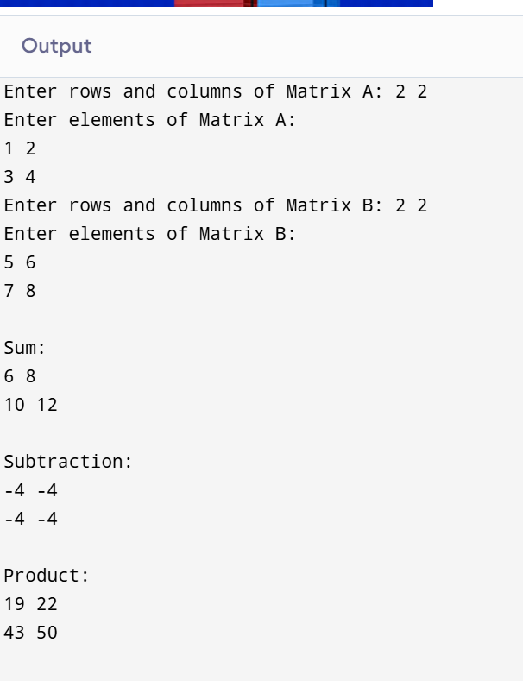
- Write a Program to sort the list using:
- Bubble Sort
- Quick Sort
- Insertion sort
- Merge Sort
- Heap Sort
Also, find the comparison on the basis of time complexity.

#include <stdio.h>
#define MAX 100
void printArray(int arr[], int n) {
for(int i = 0; i < n; i++)
printf("%d ", arr[i]);
printf("\n");
}
void bubbleSort(int arr[], int n) {
for(int i = 0; i < n-1; i++) {
for(int j = 0; j < n-i-1; j++) {
if(arr[j] > arr[j+1]) {
int temp = arr[j];
arr[j] = arr[j+1];
arr[j+1] = temp;
}
}
}
}
void insertionSort(int arr[], int n) {
for(int i = 1; i < n; i++) {
int key = arr[i];
int j = i - 1;
while(j >= 0 && arr[j] > key) {
arr[j+1] = arr[j];
j--;
}
arr[j+1] = key;
}
}
int partition(int arr[], int low, int high) {
int pivot = arr[high];
int i = low - 1;
for(int j = low; j < high; j++) {
if(arr[j] < pivot) {
i++;
int temp = arr[i];
arr[i] = arr[j];
arr[j] = temp;
}
}
int temp = arr[i+1];
arr[i+1] = arr[high];
arr[high] = temp;
return i + 1;
}
void quickSort(int arr[], int low, int high) {
if(low < high) {
int pi = partition(arr, low, high);
quickSort(arr, low, pi - 1);
quickSort(arr, pi + 1, high);
}
}
void merge(int arr[], int l, int m, int r) {
int i = l, j = m + 1, k = 0;
int temp[MAX];
while(i <= m && j <= r) {
if(arr[i] <= arr[j])
temp[k++] = arr[i++];
else
temp[k++] = arr[j++];
}
while(i <= m)
temp[k++] = arr[i++];
while(j <= r)
temp[k++] = arr[j++];
for(i = l, j = 0; i <= r; i++, j++)
arr[i] = temp[j];
}
void mergeSort(int arr[], int l, int r) {
if(l < r) {
int m = (l + r) / 2;
mergeSort(arr, l, m);
mergeSort(arr, m + 1, r);
merge(arr, l, m, r);
}
}
void heapify(int arr[], int n, int i) {
int largest = i;
int left = 2*i + 1;
int right = 2*i + 2;
if(left < n && arr[left] > arr[largest])
largest = left;
if(right < n && arr[right] > arr[largest])
largest = right;
if(largest != i) {
int temp = arr[i];
arr[i] = arr[largest];
arr[largest] = temp;
heapify(arr, n, largest);
}
}
void heapSort(int arr[], int n) {
for(int i = n/2 - 1; i >= 0; i--)
heapify(arr, n, i);
for(int i = n-1; i >= 0; i--) {
int temp = arr[0];
arr[0] = arr[i];
arr[i] = temp;
heapify(arr, i, 0);
}}
int main() {
int arr[] = {25, 12, 22, 11, 90, 34, 2};
int n = sizeof(arr)/sizeof(arr[0]);
int temp[MAX];
printf("Original Array:\n");
printArray(arr, n);
for(int i=0;i<n;i++) temp[i]=arr[i];
bubbleSort(temp, n);
printf("\nBubble Sorted Array:\n");
printArray(temp, n);
for(int i=0;i<n;i++) temp[i]=arr[i];
insertionSort(temp, n);
printf("\nInsertion Sorted Array:\n");
printArray(temp, n);
for(int i=0;i<n;i++) temp[i]=arr[i];
quickSort(temp, 0, n-1);
printf("\nQuick Sorted Array:\n");
printArray(temp, n);
for(int i=0;i<n;i++) temp[i]=arr[i];
mergeSort(temp, 0, n-1);
printf("\nMerge Sorted Array:\n");
printArray(temp, n);
for(int i=0;i<n;i++) temp[i]=arr[i];
heapSort(temp, n);
printf("\nHeap Sorted Array:\n");
printArray(temp, n);
return 0;}
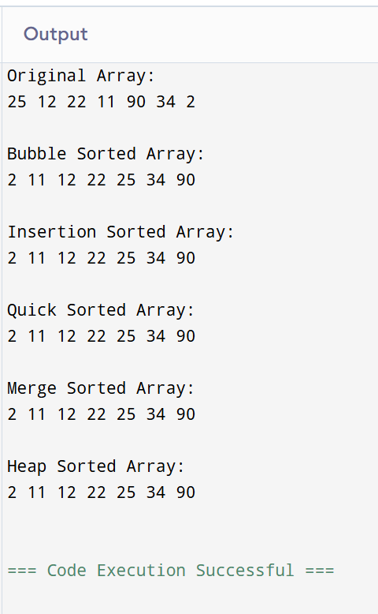

Algorithm | Best case | Average case | Worst Case
Bubble Sort | O(n) | O(n²) | O(n²)
Quick Sort | O(n Log n) | O(n Log n) | O(n²)
Merge Sort | O(n Log n) | O(n Log n) | O(n Log n)
Insertion Sort | O(n) | O(n²) | O(n²)
Heap Sort | O(n Log n) | O(n Log n) | O(n Log n)

- Write a program to search the element using:
    - Linear Search
    - Binary Search
Also find the comparison on the basis of time complexity.
#include <stdio.h>
int linearSearch(int arr[], int n, int key) {
for(int i = 0; i < n; i++) {
if(arr[i] == key)
return i;
}
return -1;
}
int binarySearch(int arr[], int low, int high, int key) {
while(low <= high) {
int mid = (low + high) / 2;

if(arr[mid] == key)
return mid;
else if(arr[mid] < key)
low = mid + 1;
else
high = mid - 1;
}
return -1;
}

int main() {

int arr[] = {2, 11, 12, 22, 25, 34, 90};
int n = sizeof(arr)/sizeof(arr[0]);
int key;
int result;

printf("Enter element to search: ");
scanf("%d",&key);
result = linearSearch(arr,n,key);
if(result != -1)
printf("Element found at position %d using Linear Search\n", result+1);
else
printf("Element not found using Linear Search\n");
result = binarySearch(arr,0,n-1,key);
if(result != -1)
printf("Element found at position %d using Binary Search\n", result+1);
else
printf("Element not found using Binary Search\n");

return 0;
}
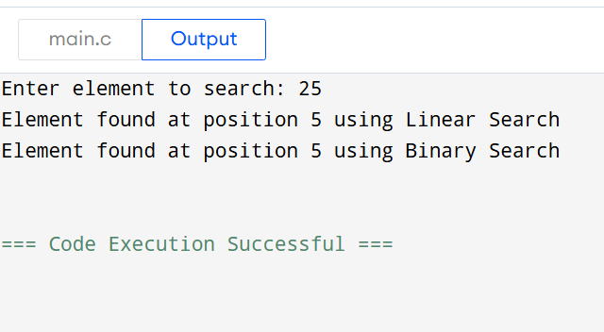

Search Algorithm | Best Case | Average Case | Worst Case
Linear Search | O(1) | O(n) | O(n)
Binary Search | O(1) | O(n Log n) | O(n Log n)

- Write a program to perform all operations:
  - For the Stack using an Array.
  - For the Queue using an Array.
  - For the Circular Queue using an Array.

#include <stdio.h>
#define MAX 5

int stack[MAX], top=-1;
int queue[MAX], front=-1, rear=-1;
int cq[MAX], f=-1, r=-1;

int main() {

printf("STACK\n");
stack[++top]=10;
stack[++top]=20;
stack[++top]=30;

for(int i=top;i>=0;i--)
printf("%d ",stack[i]);

printf("\nPopped: %d\n",stack[top--]);

printf("\nQUEUE\n");
queue[++rear]=5; front=0;
queue[++rear]=15;
queue[++rear]=25;

for(int i=front;i<=rear;i++)
printf("%d ",queue[i]);

printf("\nDeleted: %d\n",queue[front++]);

printf("\nCIRCULAR QUEUE\n");
f=r=0; cq[r]=100;
r=(r+1)%MAX; cq[r]=200;
r=(r+1)%MAX; cq[r]=300;

int i=f;
while(1){
printf("%d ",cq[i]);
if(i==r) break;
i=(i+1)%MAX;
}

printf("\nDeleted: %d\n",cq[f]);
f=(f+1)%MAX;

return 0;
}
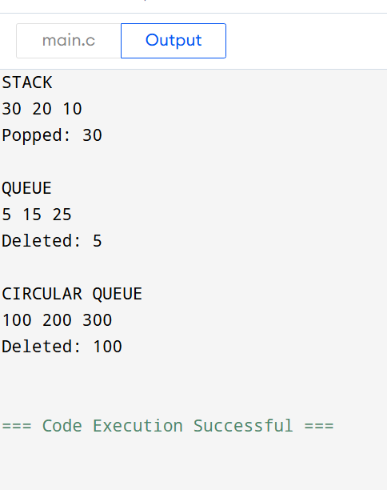

    - Write a program to evaluate the Postfix Notation.

#include <stdio.h>
#include <ctype.h>
#include <string.h>

#define MAX 100

int stack[MAX];
int top = -1;

void push(int x) {
stack[++top] = x;
}

int pop() {
return stack[top--];
}

int main() {
char postfix[MAX];
printf("Enter postfix expression (single-digit operands, no spaces): ");
scanf("%s", postfix);

for(int i=0; i<strlen(postfix); i++) {
char ch = postfix[i];

if(isdigit(ch)) {
push(ch - '0');
} else {
int val2 = pop();
int val1 = pop();

switch(ch) {
case '+': push(val1 + val2); break;
case '-': push(val1 - val2); break;
case '*': push(val1 * val2); break;
case '/': push(val1 / val2); break;
}
}
}

printf("Result: %d\n", pop());
return 0;
}

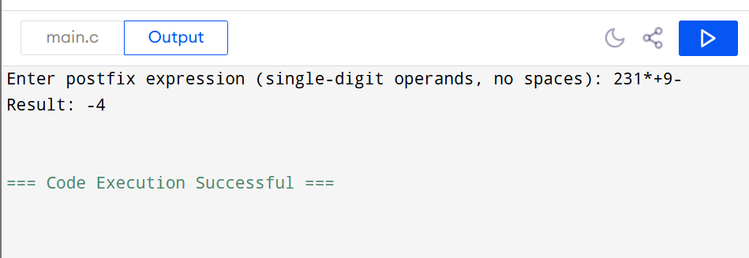
      - Write a program to convert infix notation into Postfix Notation.
#include <stdio.h>
#include <ctype.h>
#include <string.h>

#define MAX 100

char stack[MAX];
int top = -1;

void push(char x) {
stack[++top] = x;
}

char pop() {
if(top == -1) return '\0';
return stack[top--];
}

char peek() {
if(top == -1) return '\0';
return stack[top];
}

int precedence(char op) {
if(op == '+' || op == '-') return 1;
if(op == '*' || op == '/') return 2;
return 0;
}

int main() {
char infix[MAX], postfix[MAX];
int k = 0;

printf("Enter infix expression (single-digit operands): ");
scanf("%s", infix);

for(int i = 0; i < strlen(infix); i++) {
char ch = infix[i];

if(isalnum(ch)) {
postfix[k++] = ch;
}
else if(ch == '(') {
push(ch);
}
else if(ch == ')') {
while(top != -1 && peek() != '(') {
postfix[k++] = pop();
}
pop();
}
else {
while(top != -1 && peek() != '(' && precedence(peek()) >= precedence(ch)) {
postfix[k++] = pop();
}
push(ch);
}
}

while(top != -1) {
postfix[k++] = pop();
}

postfix[k] = '\0';
printf("Postfix expression: %s\n", postfix);

return 0;
}
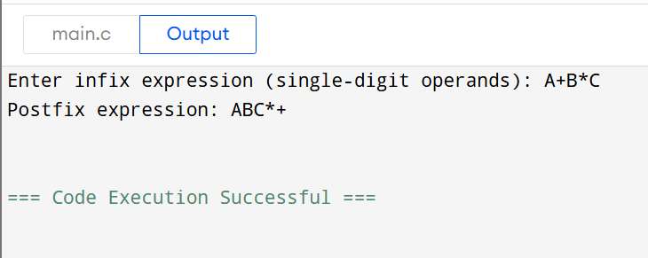
- Write a program to perform the operations of the linked list:
  - Insertion
  - Deletion
  - Display

#include <stdio.h>
#include <stdlib.h>
struct Node {
int data;
struct Node* next;
};

void insert(struct Node** head, int value) {
struct Node* newNode = (struct Node*)malloc(sizeof(struct Node));
newNode->data = value;
newNode->next = NULL;

if(*head == NULL) {
*head = newNode;
} else {
struct Node* temp = *head;
while(temp->next != NULL)
temp = temp->next;
temp->next = newNode;
}
}

void deleteNode(struct Node** head, int value) {
if(*head == NULL) {
printf("List is empty\n");
return;
}

struct Node* temp = *head;
struct Node* prev = NULL;

if(temp->data == value) {
*head = temp->next;
free(temp);
return;
}

while(temp != NULL && temp->data != value) {
prev = temp;
temp = temp->next;
}

if(temp == NULL) {
printf("Value %d not found\n", value);
return;
}

prev->next = temp->next;
free(temp);
}

void display(struct Node* head) {
if(head == NULL) {
printf("List is empty\n");
return;
}

struct Node* temp = head;
printf("Linked List: ");
while(temp != NULL) {
printf("%d ", temp->data);
temp = temp->next;
}
printf("\n");
}

int main() {
struct Node* head = NULL;

insert(&head, 10);
insert(&head, 20);
insert(&head, 30);
printf("After insertion:\n");
display(head);

deleteNode(&head, 20);
printf("After deleting 20:\n");
display(head);

deleteNode(&head, 40); // Value not in list

return 0;
}
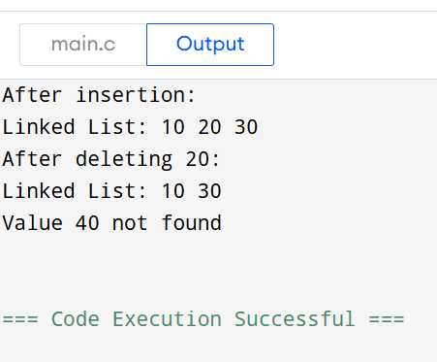
- Write a program to perform the operations of the Circular linked list:
    - Insertion
    - Deletion
    - Display
#include <stdio.h>
#include <stdlib.h>

struct Node {
int data;
struct Node* next;
};

void insert(struct Node** head, int value) {
struct Node* newNode = (struct Node*)malloc(sizeof(struct Node));
newNode->data = value;
if(*head == NULL) {
newNode->next = newNode;
*head = newNode;
} else {
struct Node* temp = *head;
while(temp->next != *head)
temp = temp->next;
temp->next = newNode;
newNode->next = *head;
}
}

void deleteNode(struct Node** head, int value) {
if(*head == NULL) {
printf("List is empty\n");
return;
}

struct Node *temp = *head, *prev = NULL;

if(temp->data == value) {
if(temp->next == *head) { // Only one node
free(temp);
*head = NULL;
} else {

struct Node* last = *head;
while(last->next != *head)
last = last->next;
last->next = temp->next;
*head = temp->next;
free(temp);
}
return;
}

prev = temp;
temp = temp->next;
while(temp != *head && temp->data != value) {
prev = temp;
temp = temp->next;
}

if(temp->data == value) {
prev->next = temp->next;
free(temp);
} else {
printf("Value %d not found\n", value);
}
}

void display(struct Node* head) {
if(head == NULL) {
printf("List is empty\n");
return;
}

struct Node* temp = head;
printf("Circular Linked List: ");
do {
printf("%d ", temp->data);
temp = temp->next;
} while(temp != head);
printf("\n");
}

int main() {
struct Node* head = NULL;

insert(&head, 10);
insert(&head, 20);
insert(&head, 30);
printf("After insertion:\n");
display(head);

deleteNode(&head, 20);
printf("After deleting 20:\n");
display(head);

deleteNode(&head, 40);

return 0;
}
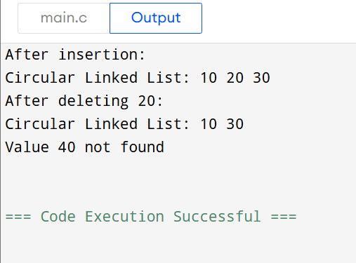
- Write a program to perform all operations:
  - For Stack using Linked List
  - For Queue using Linked List
  - For Circular Queue using Linked List

#include <stdio.h>
#include <stdlib.h>

struct Node {
int data;
struct Node* next;
};

void push(struct Node** top, int value) {
struct Node* newNode = (struct Node*)malloc(sizeof(struct Node));
newNode->data = value;
newNode->next = *top;
*top = newNode;
}

void pop(struct Node** top) {
if(*top == NULL) {
printf("Stack Underflow\n");
return;
}
struct Node* temp = *top;
printf("Popped: %d\n", temp->data);
*top = temp->next;
free(temp);
}

void displayStack(struct Node* top) {
printf("Stack: ");
while(top != NULL) {
printf("%d ", top->data);
top = top->next;
}
printf("\n");
}

struct Queue {
struct Node* front;
struct Node* rear;
};

void enqueue(struct Queue* q, int value) {
struct Node* newNode = (struct Node*)malloc(sizeof(struct Node));
newNode->data = value;
newNode->next = NULL;
if(q->rear == NULL) {
q->front = q->rear = newNode;
} else {
q->rear->next = newNode;
q->rear = newNode;
}
}

void dequeue(struct Queue* q) {
if(q->front == NULL) {
printf("Queue Underflow\n");
return;
}
struct Node* temp = q->front;
printf("Deleted: %d\n", temp->data);
q->front = q->front->next;
if(q->front == NULL)
q->rear = NULL;
free(temp);
}

void displayQueue(struct Queue* q) {
printf("Queue: ");
struct Node* temp = q->front;
while(temp != NULL) {
printf("%d ", temp->data);
temp = temp->next;
}
printf("\n");
}

struct CQueue {
struct Node* front;
struct Node* rear;
};

void cenqueue(struct CQueue* cq, int value) {
struct Node* newNode = (struct Node*)malloc(sizeof(struct Node));
newNode->data = value;
if(cq->rear == NULL) {
cq->front = cq->rear = newNode;
newNode->next = newNode;
} else {
newNode->next = cq->front;
cq->rear->next = newNode;
cq->rear = newNode;
}
}

void cdequeue(struct CQueue* cq) {
if(cq->front == NULL) {
printf("Circular Queue Underflow\n");
return;
}
struct Node* temp = cq->front;
printf("Deleted: %d\n", temp->data);

if(cq->front == cq->rear) {
cq->front = cq->rear = NULL;
} else {
cq->front = cq->front->next;
cq->rear->next = cq->front;
}
free(temp);
}

void displayCQueue(struct CQueue* cq) {
if(cq->front == NULL) {
printf("Circular Queue Empty\n");
return;
}
struct Node* temp = cq->front;
printf("Circular Queue: ");
do {
printf("%d ", temp->data);
temp = temp->next;
} while(temp != cq->front);
printf("\n");
}

int main() {
struct Node* stackTop = NULL;
struct Queue q = {NULL, NULL};
struct CQueue cq = {NULL, NULL};
push(&stackTop, 10);
push(&stackTop, 20);
push(&stackTop, 30);
displayStack(stackTop);
pop(&stackTop);
displayStack(stackTop);

enqueue(&q, 5);
enqueue(&q, 15);
enqueue(&q, 25);
displayQueue(&q);
dequeue(&q);
displayQueue(&q);

cenqueue(&cq, 100);
cenqueue(&cq, 200);
cenqueue(&cq, 300);
displayCQueue(&cq);
cdequeue(&cq);
displayCQueue(&cq);

return 0;
}
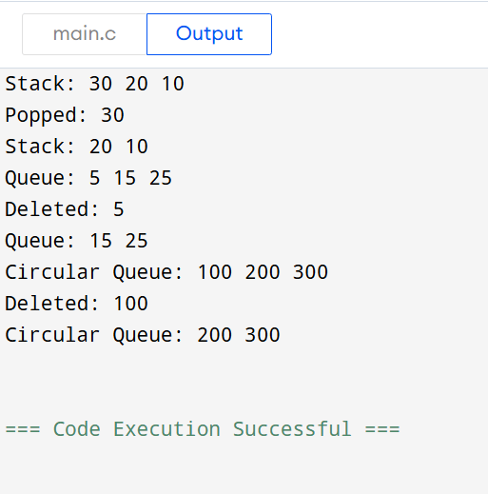
- Write a program to perform concatenation of two linked lists.
#include <stdio.h>
#include <stdlib.h>

struct Node {
int data;
struct Node* next;
};

void insert(struct Node** head, int value) {
struct Node* newNode = (struct Node*)malloc(sizeof(struct Node));
newNode->data = value;
newNode->next = NULL;

if(*head == NULL) {
*head = newNode;
} else {
struct Node* temp = *head;
while(temp->next != NULL)
temp = temp->next;
temp->next = newNode;
}
}

void display(struct Node* head) {
if(head == NULL) {
printf("List is empty\n");
return;
}
struct Node* temp = head;
while(temp != NULL) {
printf("%d ", temp->data);
temp = temp->next;
}
printf("\n");
}

void concatenate(struct Node** head1, struct Node* head2) {
if(*head1 == NULL) {
*head1 = head2;
return;
}
struct Node* temp = *head1;
while(temp->next != NULL)
temp = temp->next;
temp->next = head2;
}

int main() {
struct Node* list1 = NULL;
struct Node* list2 = NULL;

insert(&list1, 10);
insert(&list1, 20);
insert(&list1, 30);

insert(&list2, 40);
insert(&list2, 50);
insert(&list2, 60);

printf("List 1: ");
display(list1);

printf("List 2: ");
display(list2);

concatenate(&list1, list2);

printf("After concatenation: ");
display(list1);

return 0;
}
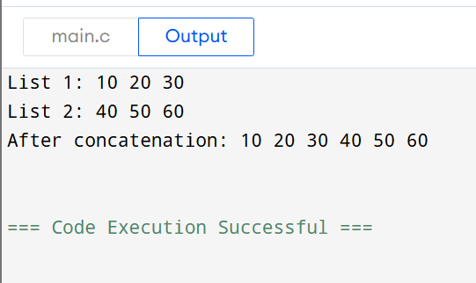
- Write a program to perform the operations of the Double linked list:
  - Insertion
  - Deletion
  - Display
#include <stdio.h>
#include <stdlib.h>

struct Node {
int data;
struct Node* next;
struct Node* prev;
};

void insert(struct Node** head, int value) {
struct Node* newNode = (struct Node*)malloc(sizeof(struct Node));
newNode->data = value;
newNode->next = newNode->prev = NULL;

if(*head == NULL) {
*head = newNode;
} else {
struct Node* temp = *head;
while(temp->next != NULL)
temp = temp->next;
temp->next = newNode;
newNode->prev = temp;
}
}

void deleteNode(struct Node** head, int value) {
if(*head == NULL) {
printf("List is empty\n");
return;
}

struct Node* temp = *head;
if(temp->data == value) {
*head = temp->next;
if(*head != NULL) (*head)->prev = NULL;
free(temp);
return;
}
while(temp != NULL && temp->data != value)
temp = temp->next;

if(temp == NULL) {
printf("Value %d not found\n", value);
return;
}

temp->prev->next = temp->next;
if(temp->next != NULL)
temp->next->prev = temp->prev;

free(temp);
}

void display(struct Node* head) {
if(head == NULL) {
printf("List is empty\n");
return;
}

printf("Doubly Linked List: ");
struct Node* temp = head;
while(temp != NULL) {
printf("%d ", temp->data);
temp = temp->next;
}
printf("\n");
}

int main() {
struct Node* head = NULL;
insert(&head, 10);
insert(&head, 20);
insert(&head, 30);

printf("After insertion:\n");
display(head);

deleteNode(&head, 20);
printf("After deleting 20:\n");
display(head);

deleteNode(&head, 40);

return 0;
}
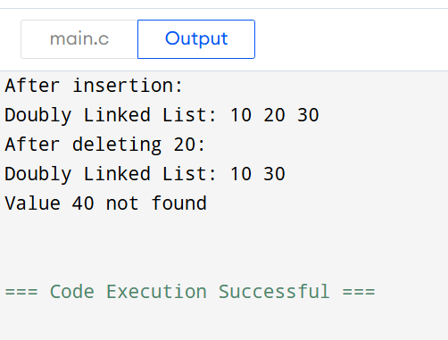
- Design and implement a queue-based appointment management system for a clinic that handles patients in the order of their arrival. The system should maintain a First-Come, FirstServed (FCFS) queue for patients and provide options to add new patients, view the next patient to be treated, serve (remove) a patient once treated, and display the list of all waiting patients.

